SP22-BCS-009 Marleen Ajmal

SP22-BCS-093 Laiba Aimen

**Assignment**

**Login**

**SignUp**

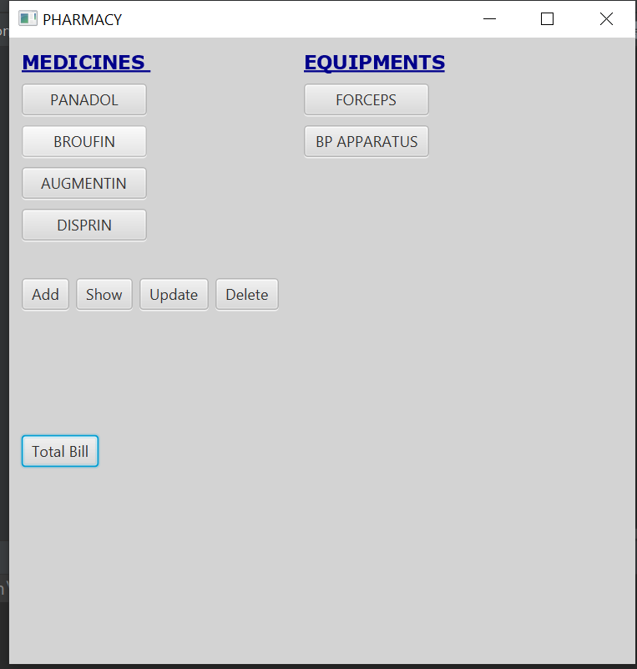

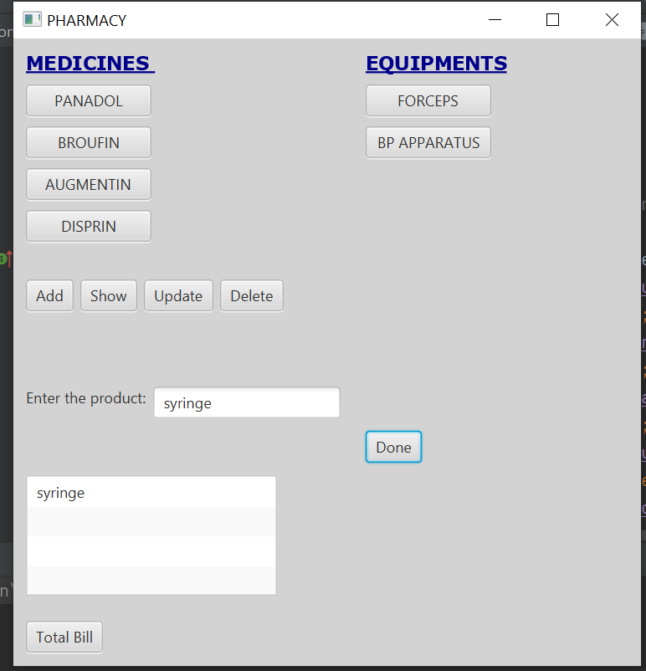

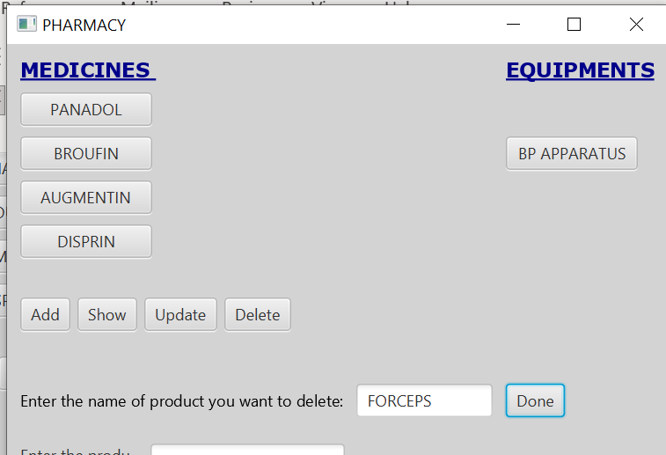

**Explanation**

public static String[] read()

This method will read from the file and return the array.

Login and signup

These will ask the user to login by entering their password and username if the user doesn’t already exist it gives the option of signup.

public static void writeInFile(String[] input)

This method will take an array as an argument and add it to the file named data.txt.

convertToArray

This method will take an ArrayList as an argument and convert it into an array and return the array.

signUp2.setOnAction

This method will take the new username and password from the user and add them to signedInArrayList.

disprinButton.setOnAction

This method will add Disprin to the ArrayList and also add Disprin to to the scene.

augmentinButton.setOnAction

This method will add Augmentin to the ArrayList and also add Augmentin to to the scene.

broufinButton.setOnAction

This method will add Broufin to the ArrayList and also add Broufin to to the scene.

panadolButton.setOnAction

This method will add Panadol to the ArrayList and also add Panadol to to the scene.

forcepButton.setOnAction

This method will add Forceps to the ArrayList and also add Forceps to to the scene.

bpApparatus.setOnAction

This method will add bpApparatus to the ArrayList and also add bpApparatus to to the scene.

signup.setOnAction

This method will take you to the signUp scene to signup.

login.setOnAction

This method will compare the typed username and password with the data of usernames and passwords in the LoggedIn class. If the username and password match then it will switch to the next scene else it will show an error message to signup first.

showButton.setOnAction

This method will show all the selected medicines on the scene in the form of ListView.

addButton.setOnAction

This method will add the selected medicines to the file by using the method writeInFile.

UpdateButton.setOnAction

This method will update the list view

DeleteButton.setOnAction

This method will delete the button

Totalbill.setOnAction

It will calculate the bill of selected medicines